Compilation

Program 1B

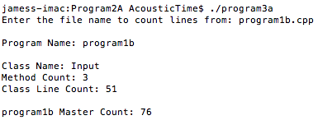

Program 2A

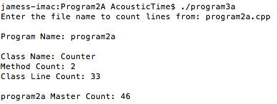

Program 3A

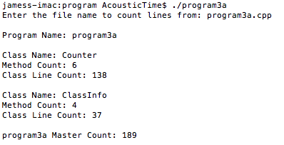

Results Table

Program # | Object Name | # of Methods | Object LOC | Total Prog LOC
1B | Input | 3 | 51
 |  |  |  | 76
2A | Counter | 2 | 33
 |  |  |  | 46
3A | Counter | 6 | 138
 | ClassInfo | 4 | 37
 |  |  |  | 189

Pseudo Code

Main Program
create Count object
pass it program filename
count method called
display report

Count Lines Method - Recursive
create new ClassInfo Object
add name of current class to object – extension
count lines and store result in ClassInfo Object
count methods and store result in ClassInfo Object
add ClassInfo object to vector
search for classes and store each name in local vector
for each class found,
run count lines method with new name which repeats above recursively

